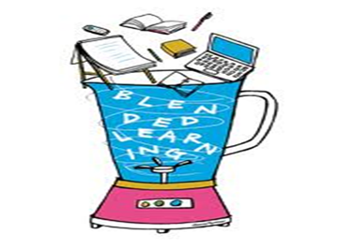
WHAT IS BLENDED LEARNING COMPONENT (BLC)?
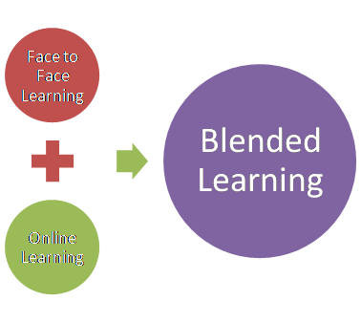
From The Handbook of Blended Learning, Curtis J. Bonk & Charles R. Graham

WHY DO WE HAVE THE BLC?

- Growing student numbers

- Space and time constraints

- Students who lack effective study skills

- Students who are digitial natives

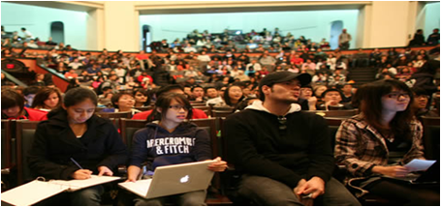

SO…
BLC is needed to provide students with more access to quality learning experiences, and encourage a more active rather than passive approach to learning while achieving institutional goals and learning objectives.

